


Dump Trailer

Safety Inspection Points

1. 1. Prior driver’s vehicle inspection report for safety defects
2. Gauges, windshield for cracks or obstructions, mirror adjustment
3. Horn, windshield wipers and fluid, steering wheel for play
4. Brakes for excessive air loss (4 pounds per minute)
5. Registration/permit book and shipping documents

2. 1. All lamps and reflectors
- Turn signals and emergency 4-way flashers
- HUT Decal and condition of Lic Plate
- Under tractor for fluid leaks

3. 1. Tire, wheel (cracks), lugs. Studs – tread depth must be at least
4/32 of an inch also check for defects and inflation level
- Wheel seal, hub
- Suspension
- Brake hose, air chamber, slack adjuster
- Steering components including steering box and pitman arm

4. 1. Fuel and air tanks for securement/leaks
2. DOT markings and IFTA decal.
- Securement/condition of air hoses and electric line/connections
- Condition of glad hands/grommets and chaffing issues
- Verify product identification number, when required, and the proper
placard against the shipping papers

5. 1. Tires, wheels (cracks), lugs, studs – tread depth must be at least
2/32 of an inch also check for defects and inflation level
- Suspension including leaf spring hangers
- Fifth wheel mounting to frame
- Brake hoses, air chambers, slack adjusters
- Verify permit decals and wheel seal at hub

6. 1. Locking mechanism for the fifth wheel
- Signs of damage to the tractor frame
- Recheck inside tire walls, wheel seals, brakes, air hoses and chambers,
and the suspension on both sides of the tractor from this angle

7. 1. Verify product identification number, when required, and the proper
placard against the shipping papers.
- Damage to the side of trailer and possible product leakage.
- General check of the side and bottom of the trailer including lights
- Condition of reflective tape

8. 1. Brake hoses (condition and chaffing), air chambers and air tank(s)
- Inside tire walls, brake components including lining and wheel seals
- Suspension components and distance to frame or bottom of trailer

9. 1. Tires, wheels (cracks), lugs, studs – tread depth must be at
least 2/32 of an inch also check for defects and inflation levels
- Check suspension including leaf spring hangers and wheel seal on hub
- Check for ABS Lamp operation and marking

North American Transportation Consultants, Inc.

Your Total Transportation and Safety Consultants

P.O. Box 1404 - Hightstown, NJ - 08520

609-426-0555 - www.49cfr.com
Copyright © 2023 NATC, Inc.

10. 1. Verify product identification number, when require, and proper
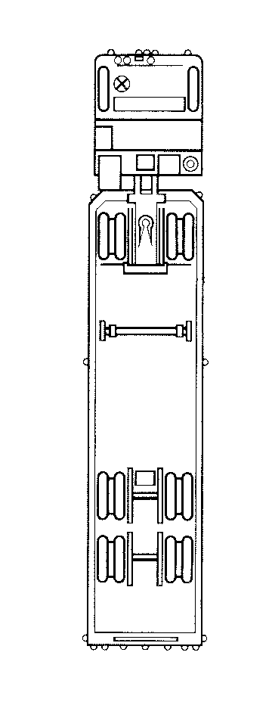
placard against the shipping papers
- Placards must not be obstructed and must be point on point
- Size, location and condition of the rear end protection
- Underneath the rear of the trailer, suspension, brakes,
wheel seals, tire condition, and air hoses, brake chambers
and tanks
- Verify permit decals along with mudflap and reflective tape

11. 1. Tires, wheels (cracks), lugs, studs – tread depth must be at
least 2/32 of an inch and check for defects and inflation
- Recheck suspension including leaf spring hangers
- Wheel seal on hub

12. 1. Damage to the side of the trailer
2. Condition of reflective tape and lights
- Verify product identification number, when required, and the
Proper placard against the shipping papers

13. 1. Tires, wheels (cracks), lugs, studs – tread depth must be
at least 2/32 of an inch and check for defects and inflation
- Check suspension including leaf spring hangers
- Brake hoses, air chambers, slack adjusters
- Verify permit decals
- Wheel seal on hub

14. 1. Fuel and air tanks for leaks and proper attachment
- Exhaust system for leaks and attachment
- DOT markings and IFTA decal

15. 1. Tire, wheel (cracks), lugs. Studs – tread depth must be at least
4/32 of an inch (recapped tires are not allowed on steering axle)
Also check for tire damage and inflation.
- Wheel seal, hub
- Suspension components and look for rub marks
- Brake hose, air chamber, slack adjuster
- Steering components

16. 1. Fire extinguisher (at least 10BC rating)
- Three, bi-directional triangle reflectors
- Replacement fuses, if required
- Sign the bottom of the previous driver’s vehicle inspection
report as required by "49CFR 396.13”

North American Transportation Consultants, Inc.

Your Total Transportation and Safety Consultants

P.O. Box 1404 - Hightstown, NJ - 08520
609-426-0555 - www.49cfr.com
Copyright © 2023 NATC, Inc.

